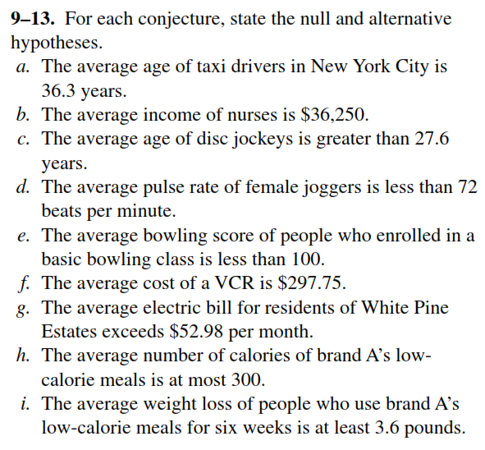

**Example 01)** The proportion of families buying milk from company A in a certain district of a city believed to be p = 0.6. if a random sample of 10 families shows that 3 or less buy milk from company A, we shall reject the hypothesis that p = 0.6 in favour of alternative p < 0.6. Find the probability of committing a type – I error if the true proportion is p =0.6. Evaluate the probability of committing a type –I error for the alternatives p = 0.3, and p = 0.4.

Example 02) A sample of size 100 is taken from a normal population with unknown mean µand known variance 36. An investigator wishes to test the hypotheses Ho: µ = 65, H1: µ > 65. He deides on the following criteria:

Accept Ho if the sample mean is less than or equal to 66.5

Reject Ho if the sample mean is greater than or equal to 66.5

Find the probability that he makes Type – I error

**Testing of a population Mean**

|  |  |  |  |
| --- | --- | --- | --- |
| **Level of Significance** | **0.10** | **0.05** | **0.01** |
| H1: µ > µo or µ < µo | +1.28, - 1.28 | +1.64, -1.64 | +2.33, -2.33 |
| H1: µ ≠ µo | +1.64, -1.64 | +1.96, -1.96 | +2.58, - 2.58 |

**Example # 01)** An electrical firm manufactures light bulbs that have a length of life that is approximately normally distributed with a mean of 1600 hours and a standard deviation of 80 hours. Test the hypothesis that µ = 1600 hours against alternative µ ≠ 1600 hours if a random sample of 30 bulbs has an average life 1576 hours. Use a 0.01 level of significance.

**Example # 02)** A sample of 16 observations is taken from a normal population whose standard deviation σ = 30. The mean is computed as 110. Test the hypothesis that µ = 100 against the alternative µ > 100 at 0.05 level of significance.

**Example # 03)**  A random sample of 64 observations has a mean 36 and standard deviation s = 5. Test the null-hypothesis Ho: µ = 40, Vs H1: µ < 40, assuming alpha = 0.05.

**Example # 04)** A researcher claims that the average wind speed in a certain city is 8 miles per hour. A sample of 32 days has an average wind speed of 8.2 miles per hour. The standard deviation of the sample is 0.6 mile per hour. At ἀ= 0.05, is there enough evidence to reject the claim?

**Example # 05)** A random of sample of size n1 = 50 taken from normal population with a standard deviation σ1 = 7.35 has sample mean 181. A second sample of size n2 = 72 taken from a different normal population with σ2 = 4.81 has sample mean 176. Test the hypothesis at 0.05 level of significance that µ1 = µ2, vs. µ1 ≠ µ2.

**Example # 06)** A farmer claims that the average yield of wheat of variety A exceeds the average yield of variety B by at least 12 bushels per acre. To test this claim, 50 acres of each variety are planted and grown under similar conditions. Variety A yielded on the average, 86.7 bushels per acre with a **standard deviation of 6.28** bushels per acre, while variety B yielded, on the average 77.8 bushels per acre with a **standard deviation of 5.61** bushels per acre. Test the farmer’s claim at alpha = 0.01.

**Example # 07)** A random sample of size 80 from a non-normal population yielded the sample mean ${\overline{x}}_{1}=170.4$ and $s_{1}^{2}=62.80$. Another sample of size 100 from a second non-normal population yielded the sample mean ${\overline{x}}_{1}=165.3$ and the sample variabce $s_{2}^{2}=89.64$. Test Ho: µ1 - µ2 ≤ 2 at alpha = 0.01.